THE WEEK IN 7 CHARTS
19th of October

------------------------------------------------------------------------------------------------------------------------------

Chart #: US inflation is heating up again

Headline inflation rose to 3.7% year-on-year in September, its highest reading since May.

Higher gasoline and diesel prices accounted for much of the rise, while airfares and used-car prices added to the pressure. Monthly inflation reached 0.6%, the largest increase since May.

Stripping out food and energy, the picture also worsened: core inflation climbed to 2.6% from 2.4% in August, above expectations.

Households are clearly being squeezed: prices have risen 3.7% over the past twelve months, ahead of average wage growth of 3%.

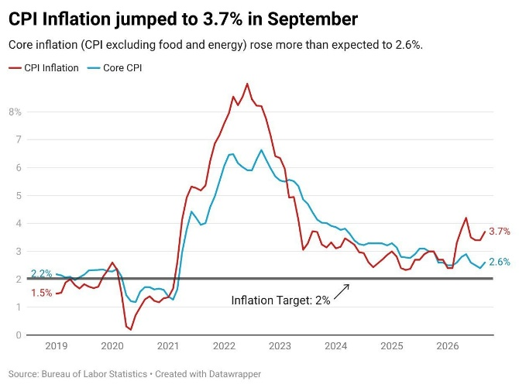

Source: Heather Long on X, BLS

Chart #: The power of magazine cover stories

US Treasury yields are falling sharply, even though US CPI and PPI inflation figures came in above expectations. The move comes only days after The Economist ran a cover story asking whether the bond market was about to blow up.

Magazine covers have frequently proved to be strong contrarian signals for investors.

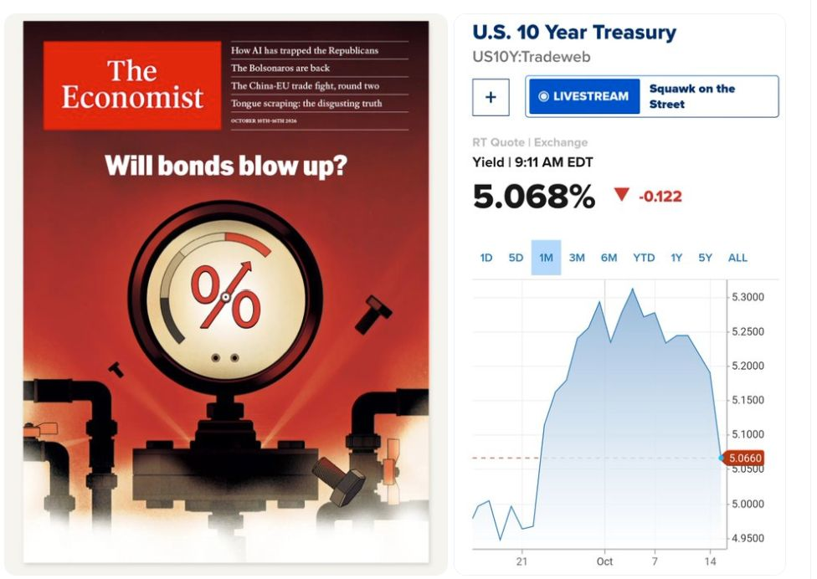

Source: Ryan Detrick
Chart #: So far in H2, Hyperscaler debt issuance dwarfs emerging market

Since the 1st of July, two hyperscalers alone (Amazon and Alphabet) have issued more debt than all emerging-market governments combined.

Amazon and Alphabet have raised around $126 billion this year, compared with roughly $41 billion for emerging-market sovereigns.

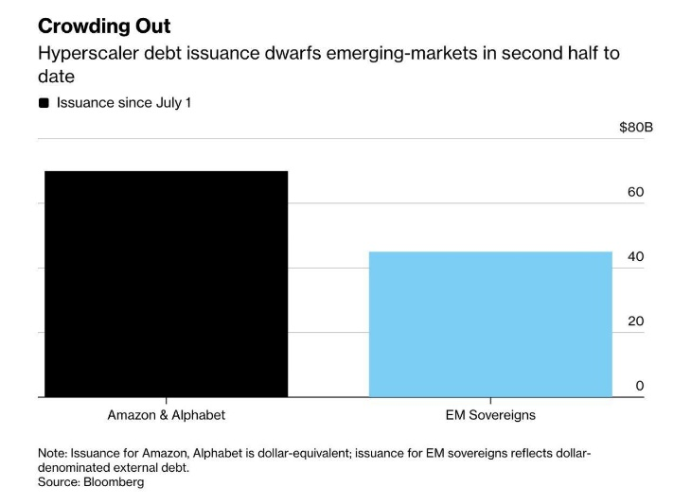

Source: Nic
@puckrin on X

Chart #: The world continues to spend more on alcohol than AI infrastructure

Spending in 2026:
• Alcohol: $1.70B
• AI infrastructure: $1.484B

Forecasts suggest that next year AI spending will overtake alcohol for the first time.

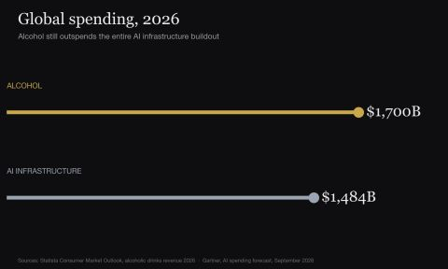
Source: Michael Burry Stock Tracker ♟
@burrytracker

Chart #: AI’s biggest disruption may be the collapse in its cost

AI costs are falling faster than those of any previous transformative technology, 54 times faster than electricity, and the pace has held steady since GPT-3.

Declines that took other technologies decades seem to be unfolding in AI over just a few years.

The economic consequences are significant: as intelligence gets cheaper, more tasks become worth automating, personalising or improving. Lower costs can boost demand sharply, even as prices decline.

For investors, this brings both opportunity and pressure. Businesses that use AI could gain from cheaper access, while providers whose products become interchangeable may see their margins squeezed. Surging usage does not necessarily translate into higher profits.

A caveat: the chart neither defines the benchmark used for AI costs nor cites a source. Its striking scale should be verified, and the technologies compared are measured in different units.

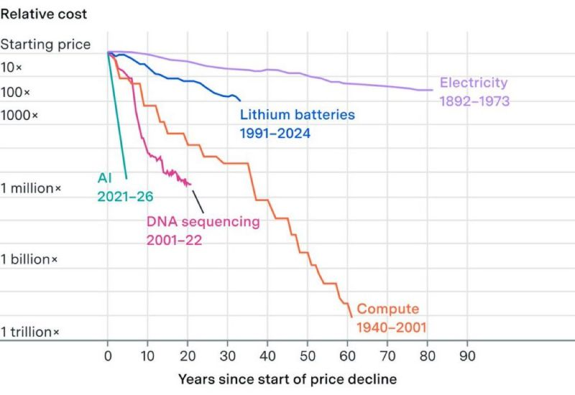

Source: Linus ✦ Ekenstam
@LinusEkenstam

Chart #: The United Kingdom has purchased the most amount of French bonds out of any nation

This leaves the UK most exposed to contagion and losses should France default on its debt or need a loan from the IMF and the European Central Bank.

When Greece went through this during the 2011 European banking crisis, youth unemployment soared to 60% by 2013.

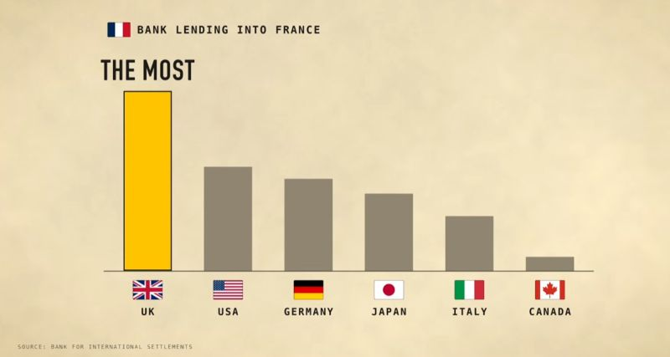

Source: Financelot
@FinanceLancelot

Chart #: China has a K-shaped economy

September brought China another huge trade surplus of $133.5 billion, as exports jumped 36.3% year-on-year.

Hoping that Beijing will move away from export-led growth any time soon seems unrealistic.

The Chinese economy is taking an increasingly K-shaped form:

• The upper arm: exporters and advanced manufacturers are benefiting from global demand for chips, AI infrastructure and green technology.

• The lower arm: households are contending with property-related wealth losses, a weak job market and pressure to pay down debt. Consumption stays subdued as families shore up their finances.

Factories can prosper even as consumers feel worse off.

As a result, Beijing relies heavily on foreign demand to offset weakness at home, which makes a swift shift away from exports unlikely.

Until Chinese households regain the confidence to spend, the rest of the world will continue to absorb the output of China’s factories.
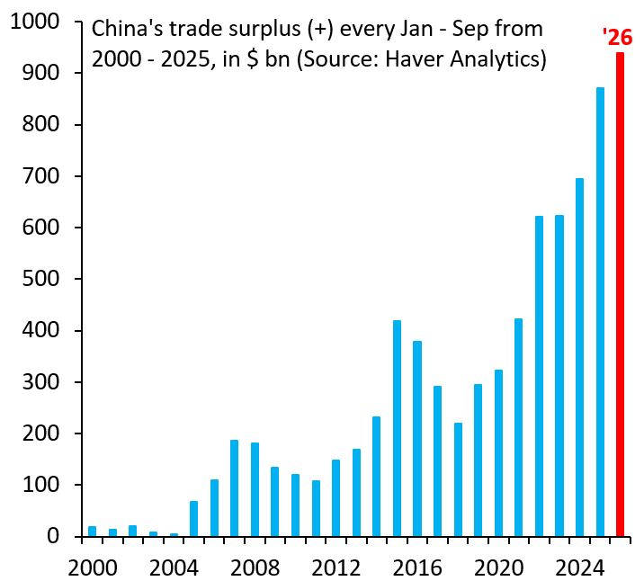

Source: Robin Brooks

